|  |
| --- |
| *Ahsanullah University of Science & Technology*logo.jpgDepartment of Computer Science & Engineering |
| **Smart Home** |
| NETWORK PROGRAMMING (CSE-425) |
|  |
|  |
|  |

|  |  |
| --- | --- |
| **Submitted By:** | |
| Rifat Ut Tauwab | 11.01.04.038 |
| Tazim hoque | 11.01.04.055 |
|  |  |

|  |
| --- |
|  |

Introduction

The concept of our project is based on remote home controlling system. Using this project people can observe their homes electric devices condition and also can control the electronic devices/machines (most common devices or machines used in home) via internet. We are providing a Website interface for registered users to monitor their home. So whenever anyone worried about their home or want to monitor it, they can take a look to their home from anywhere in the world throw our website.

Motivation:

People are too busy in these days; they have to work on various places far away from their home. Sometimes they are worried about their home. So, we think if we can make an easy and a quick system by which anyone can monitor their home over internet it will be really helpful for them. Sometimes people also forget to shut down their electronic machines most commonly like as fan, light etc. If there is a way to control those machines remotely from anywhere, it will be more power consuming. Altogether those thoughts motive us to make this project.

Architecture:

We used three tier architecture, those are described below:

**1st tier:** The Website where user can login and monitor their home devices. There is also a software interface available for controlling those electric devices from user PC. These tier provides a simple graphical interface with easy controlling system for users.

**2nd tier :** Web Server that controls and maintain user commands. It provides information to the users home devices server and also receives information from home server. A software running in the home server communicates with the Web Server to get and send information.

**3rd tier :** There is two main datasets (information about home electric devices) , one in the local server[users home device] and another in the webserver.

Technologies and Platform:

**For Home**  
 Device: Desktop or Laptop Computer

OS: Windows

Programming Language : Java, C   
 **Hardware**: Arduino uno, Logic Gate- AND Gates , LED Light, Switchs

**For Website**

**Web programming**: JSP, HTML, CSS3, Servlet   
 **Server:** Apache Tomcat

Functionalities:

For this project there is a website for the users who will get registered in this project service. They will be given a user name and password to check their home status by login to that website. Hardware setup in their home will be done manually by us. A software on the users home pc will provide to monitor the status[ON/OFF] of the electronic machines connected to a microcontroller.

**User Side**

In the website users have a simple graphical view of their rooms in home containing the status of the electronic machines [ON/OFF]. They also have the option to power on or shut down any of those machines using that website. We used a JSP web page to display the graphical view. The page contains information about the users rooms electric devices running status, this information is provided to this page by a Servlet page named MyHomeStatus.java . From users home page they can also send command to their home devices for shut down or Power On, which is maintained by another Servlet page named BtnClickRes.java .

**Server Side**

For this project there are some hardware configuration and a software to monitor the signals from the hardware part in users home. We used microcontroller Arduino uno for receiving signals from the electronic devices and checking their status[ON/OFF].

The software running in the host device[PC or Laptop] keeps track of the status of the machines. This information(machine status) is sent to the web server by a java application form named sendData.java . Another java form named WebUpdate.java receives user commands from the web server. Using those commands a java form named Room1.java takes action to change the status of the connected machines and displays the output.

In website when an user changes the status of a machine [ON/OFF], BtnClickRes.java servlet page writes that command in a text file, so that the WebUpdate.java form from user PC can get the user updated command. Correspondingly in web MyHomeStatus.java receives user home devices status from desktop form MyHomeStatus.java and makes update to users JSP home page.

Project Interface:

**Desktop Application:**

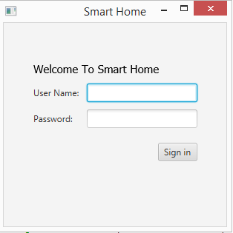

Fig: Desktop Login Form

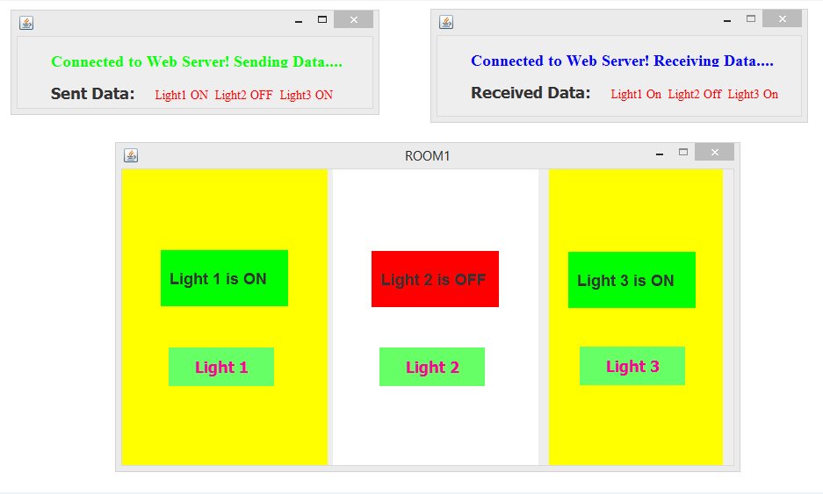

Fig: Desktop Room Controller Forms

**Website:**

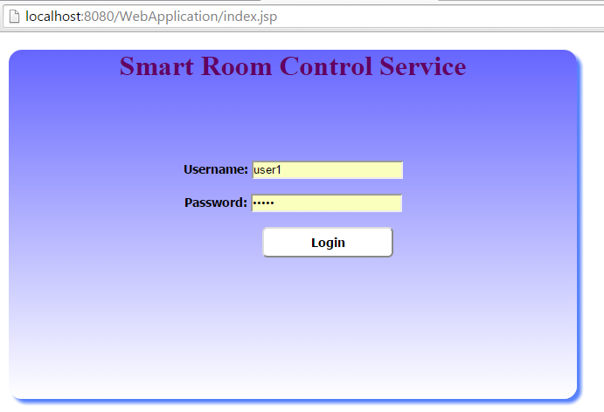

Fig: Website Login Page

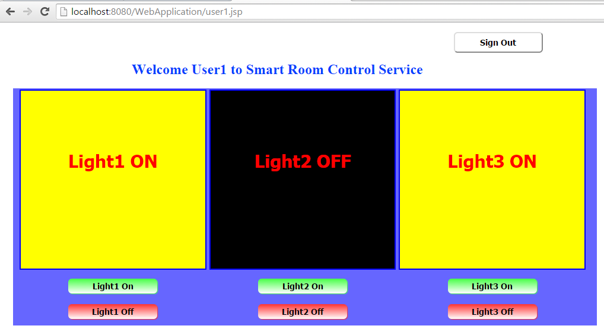

Fig: Website User Home Page

**Hardware:**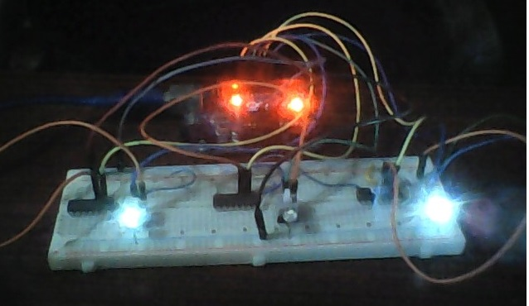

Fig: Circuit Board connection with Arduino

Conclusion:

We have some future plans to increase the facilities and more functions. We will try to provide a visual of the home using webcam. This project requires a strong hardware support working besides software and web control. This is kind of a big project but we tried to complete as far we could within this time.